Literacy support worksheet answers

7.1 Displacement is change in position with direction

Pages 156–157

Distance and displacement

1 Complete the following table by writing the correct definitions in the spaces provided. Complete the second column of the table below with your definitions, showing your understanding of the key terms to the left. Once you have finished, discuss with someone else in your class, and write down their understanding of the key terms in the third column.

|  |  |  |  |
| --- | --- | --- | --- |
| **Key term** | **My understanding of this term** | **My classmate’s understanding of this term** | **Actual definition** |
| Distance | Student answers will vary. | Student answers will vary. | How far an object travels over a certain period of time. |
| Displacement | Student answers will vary. | Student answers will vary. | A vector quantity that measures the change in position of an object and its direction over a certain period of time. |
| Scalar quantity | Student answers will vary. | Student answers will vary. | A quantity that only has size (or magnitude) and no direction (e.g. distance). |
| Vector quantity | Student answers will vary. | Student answers will vary. | A quantity that has size and direction (e.g. velocity, displacement). |

2 Name two reasons why displacement is a vector quantity.

Because it has position and direction.

3 Name two ways to represent the movement of an object.

• position–time graphs

• distance and displacement diagrams

4 A girl rides a skateboard. Her journey is shown on the graph below.

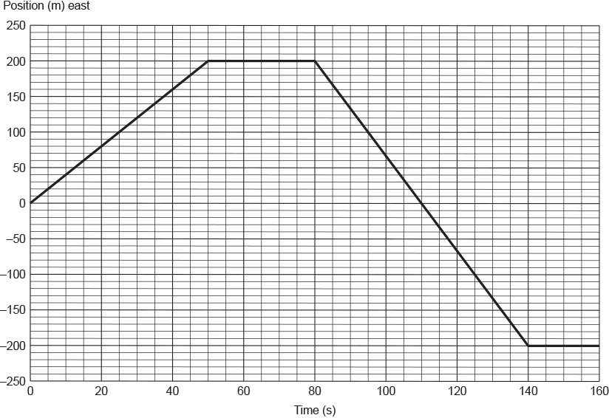

a How far did the girl travel in 160 seconds?

In 160 s the girl travelled a total distance of 200+400 = 600m

b What was the girl’s displacement at each of the following times? The first one has been done for you.

i *t* = 50 s

200 m

ii *t* = 110 s

0 m

iii *t* = 110 s

–200 m

Word detective – Fill in the blanks

5 Use the following word list to fill in the blanks in the sentences below to describe the girl’s motion as shown on the graph in question 4.

Word list: 400 m, constant, starting, opposite, doesn’t move

For example: From *t* = 0 s to *t* = 50 s, the girl travelled a distance of 200 m.

a From *t* = 50 s to *t* = 80 s the girl doesn’t move.

b From *t* = 80 s to *t* = 140 s the girl travelled at a constant speed but in the opposite direction to her original motion.

c At *t* = 110 s she passed her starting point.

d She travelled a total distance of 400 m during this time interval.

Literacy support worksheet answers

7.2 Velocity is speed with direction

Pages 158–159

Speed and velocity

1 Explain the difference between speed and velocity by completing the table below.

|  |  |
| --- | --- |
| **Speed** | **Velocity** |
| Speed is a measure of how fast a car or a person or any moving object is travelling. | Velocity is speed in a particular direction and is therefore a vector quantity. |

2 Look at the two equation triangles. Label which triangle can be used to calculate speed and which triangle can be used to calculate velocity.

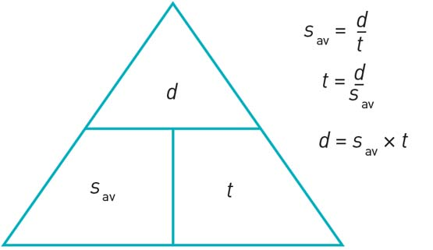

Speed

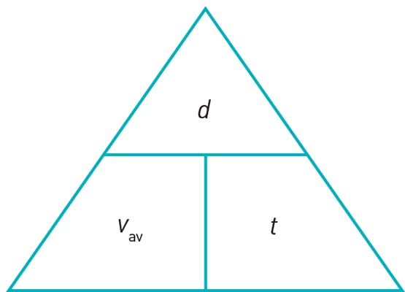

Velocity

3 Use the formula triangle for velocity to show the following formula. The first one has been done for you.

a Displacement = Average speed multiplied by time

b Time = Displacement divided by average velocity

c Average velocity = Displacement divided by time

4 In 2009 Usain Bolt ran 100 metres in 9.58 seconds. It was a new world record. What was his average speed for the race? Solve, using the equation below.







Word detective – Write a story

5 Create a story that would explain the movement on the graph shown below.

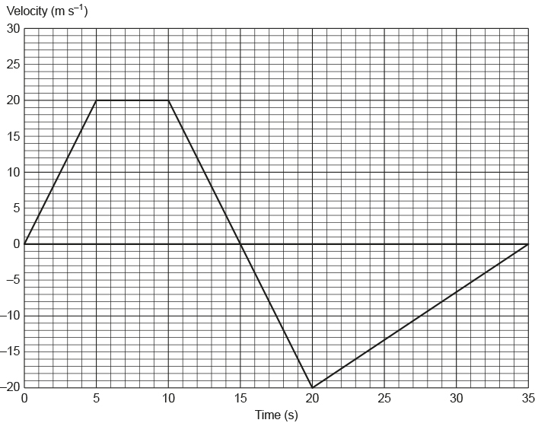

Student answers will vary but should include a reason to explain each change in speed and velocity.

Literacy support worksheet answers

7.3 Acceleration is change in velocity over time

Pages 160–161

Acceleration – speeding up and slowing down

1 Complete the following sentences:

a ‘Acceleration is the rate at which the speed of an object changes.’

b ‘Deceleration is the rate at which the speed slows down.’

c ‘Gravity acceleration is the increase in speed of an object as it falls under the influence of gravity.’

2 Imagine a marble rolling along a table.



List two ways that you could:

a change its speed but not its direction.

Student answers will vary but could include: increasing the gradient or slope, using a fan to push the marble and so on.

b change its direction but not its speed.

Student answers will vary but could include: using a pre-made track, using a straw to blow the marble in a certain direction and so on.

3 The graph below shows an object travelling at a constant speed at first. What happens to the object’s speed next?

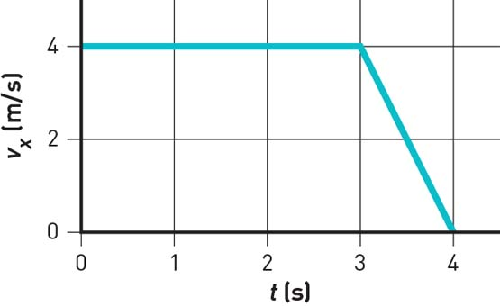

It will decelerate or slow down.

4 In the space provided below, draw another speed–time graph that shows an object accelerating quickly before beginning to travel at a constant speed.

Student graphs will vary based on the times they have chosen, but should show a line with a steep gradient that becomes a horizontal line further along the x-axis.

Word detective – Draw and explain

5 Draw a speed–time graph showing a steep gradient and a gentle gradient and explain what each one means. (Hint: Use the information in Figure 7.15 in the student book as a guide.)

Student graphs will vary based on the times they have chosen but will include similar diagrams to those in Figure 7.15.

Literacy support worksheet answers

7.4 An object in motion remains in motion until a force acts on it

Pages 162–163

Newton’s first law: Inertia

1 Use the following word list to fill in the blanks in the paragraph below.

Word list: mass, rest, constant, inertia, unbalanced

Newton’s law of inertia states: An object remains at rest or in constant motion in a straight line unless acted on by a net unbalanced force. The greater the mass of an object, the larger the inertia.

2 Which of the two shopping trolleys shown in the diagram below has the greatest inertia? Explain your answer.



The shopping trolley full of groceries has a greater inertia than the empty trolley because the full trolley has a greater mass.

3 The diagram below shows a stack of five coloured circular disks made of smooth, polished wood. The plunger is hit quickly and firmly by the hand.

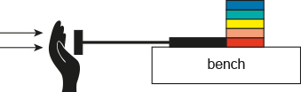

a Fill in the blank in the sentence below.

Due to the law of inertia, objects at rest will stay at rest until acted on by a net unbalanced force.

b There will be an unbalanced force, due to the plunger, on which coloured disk?

There will be an unbalanced force on the red disk.

c Which way will this disk be pushed?

The disk will be pushed to the right.

d What will the other disks do?

The other disks will sit on top of the plunger without having moved forward.

4 Why might a penguin be able to keep sliding quickly across a flat icy surface? (Hint: Use the law of inertia to explain your answer.)

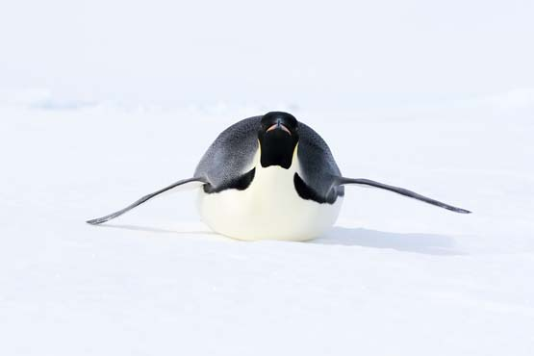

There is no friction acting against the penguin’s motion, therefore there is no need for any additional force to be applied to the penguin to keep it moving. It will continue to move across the ice in the same direction at 2.0 m s–1. This is because of the law of inertia that states that an object will travel with a constant velocity (speed and direction) until it is acted upon by unbalanced force.

Word detective – Sequencing

5 Michaela took a ride on an amusement park ride called the Space Shot.

The experience included the following, as described by Michaela:

• At the start of the ride at ground level, Michaela said that she felt like she was being pushed very hard downwards into her seat.

• She then felt confused because she knew that she was moving upwards very quickly.

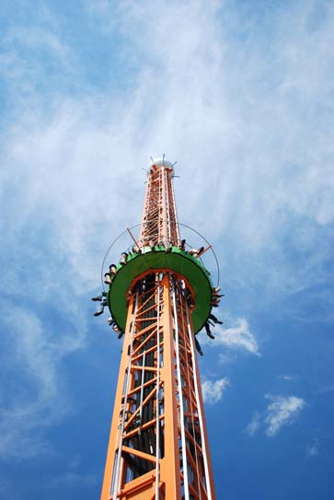

Below is an explanation of what happened to Michaela at the start of the ride. Write a number next to each of the sentences below to put them in the correct order.

4 Michaela will then feel as if she is being pushed very hard back into her seat.

1 Initially Michaela was at rest on the seat. Due to her inertia, her body ‘wants’ to remain at rest.

3 According to Newton’s 3rd law of motion, Michaela will push back on her seat with the same amount of force that it is pushing her with.

2 When the ride starts and the seats accelerate upwards, Michaela’s seat pushes and accelerates her upwards.

Literacy support worksheet answers

7.5 Force equals mass × acceleration

Pages 164–165

Newton’s second law: *F*net = *m × a*

1 The cyclist in the diagram below is not in a state of constant motion because the forces acting on him are unbalanced.

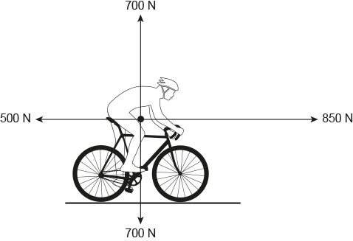

a How is the cyclist in the diagram able to accelerate and move forward?

Answers will vary but could include a description of how the force of motion forward is greater than the force of motion backward, so the cyclist will accelerate forwards.

b In the diagram above, the horizontal force is 350 N. How was this force calculated? (Hint: Use the information in Figure 7.29 and the information on page 165 in the student book to help you.)

850 N – 500 N = 350 N

2 Use the equation below to calculate the force the cyclist will hit the ground with if the mass of the cyclist (*m*) is 85 kg and his acceleration over the top of the bike (*a*) is 5.0 m s–2.

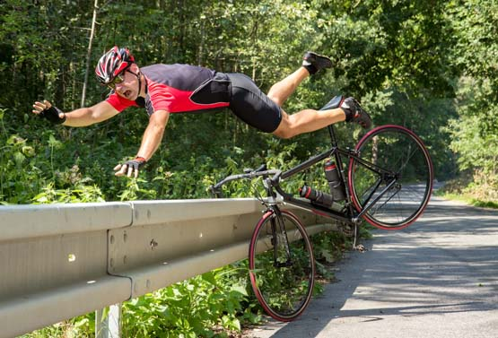

Net force (in Newtons, N) = mass (in kg) × acceleration (in m s–2)

*F*net = *m* × *a*



3 How much horizontal net force is required to accelerate a 1200 kg car (*m*) at 1.5 m s–2 (*a*)?

Remember: Net force (in Newtons, N) = mass (in kg) × acceleration (in m s–2)

*F*net = *m* × *a*



Word detective – Draw and label

4 Draw a cyclist and label how different the various forces are acting on him.

Student drawings will vary but will include similar diagrams to those in Figures 7.24, 7.25 and 7.29.

Literacy support worksheet answers

7.6 Each action has an equal and opposite reaction

Pages 166–167

Newton’s third law: *F*ab = –*F*ba

1 ‘For every action, there is an equal and opposite reaction on the other object.’ What is this statement known as?

It is known as Newton’s 3rd law of motion.

2 Give an example of an action–reaction pair.

Student answers will vary but might include: leaning on a wall, a balloon flying through the air.

3 For each of the following situations, describe the action and reaction forces. Remember that each force acts on a different item in the object pair. The first two have been done for you.

|  |  |  |  |
| --- | --- | --- | --- |
|  | Situation | Action | Reaction |
| a | A rocket taking off from its launch pad.  SW0723_01095-r | The action force is the rocket engine pushing out the hot exhaust gases. | The reaction force is the hot exhaust gases pushing the rocket upwards. |
| b | A tennis racquet hitting a tennis ball.  SW0724_01095-r | The action force is the tennis racquet hitting the tennis ball. | The reaction force is the tennis ball pushing back on the tennis racquet. |

|  |  |  |  |
| --- | --- | --- | --- |
| c | A sprinter pushing off from the starting blocks.  SW0725_01095-r | The action force is the sprinter’s feet pushing against the starting blocks (ground). | The reaction force is the starting blocks (ground) pushing back on the sprinter. |
| d | A footballer marking a football.  SW0726_01095-rf | The action force is the footballer’s two hands pushing against the football. | The reaction force is the football pushing back on the footballer’s two hands. |

(Note: In all instances, the reaction force is of the same size (magnitude) as the action force.)

Word detective – Fill in the blanks



4 Fill in the blanks in the sentences below. The sentences refer to the gymnast pictured above, hanging from a set of rings.

The action force is weight provided by the gravitational force the earth exerts on the gymnast.

The reaction force is the gravitational force the gymnast pushes down on the earth.

Literacy support worksheet answers

7.7 Momentum is conserved in a collision

Pages 168–169

Momentum

1 What is momentum?

Momentum is the product of an object’s mass and its velocity.

2 For each of the following three situations, calculate the size of the object’s momentum.

Remember: momentum (*p*) = mass (*m*) × velocity (*v*)

a A speed skater of mass (*m*) of 75 kg moving with a velocity (*v*) of 5.8 m s–1.

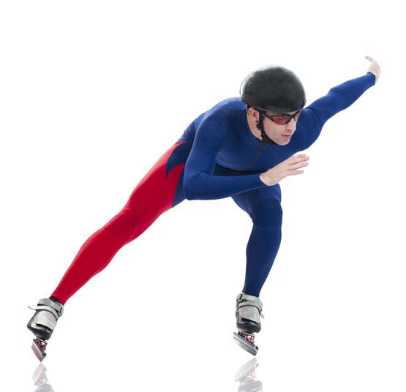



b A tennis ball of mass (*m*) 58 g travelling at 180 km h–1 (*v*).



To convert grams to kilograms:



To convert kilometres per hour (km h–1) to metres per second (m s–1):





Word detective – Draw and explain

3 Draw two dodgem cars before a crash and after a crash. (Hint: Use the information in Figure 7.35 in the student book as a guide.)

Before crash

Student drawings will vary but will include similar diagrams to those in Figures 7.35.

After crash

Student drawings will vary but will include similar diagrams to those in Figures 7.35.

4 Summarise how you would calculate each of the following from question 3 above:

a The initial momentum of each car.

Initial momentum is calculated by multiplying the car’s mass by its initial velocity, or *p* = *m* × *u*.

b The final momentum of one car if it has stopped after the crash.

If the car is it not moving it has no momentum.

Literacy support worksheet answers

7.8 Work occurs when an object is moved or rearranged. Energy can be calculated

Pages 170–171

Work, kinetic energy, gravitational potential energy and elastic potential energy

1 Complete the table by identifying which of the following terms belong to each definition:

Word list: work, gravitational potential energy, elastic potential energy, kinetic energy

|  |  |
| --- | --- |
| Term | Definition |
| Work | Occurs whenever an object is moved by a force. |
| Kinetic energy | The energy possessed by moving objects. |
| Gravitational potential energy | The energy possessed by objects raised to a height in a gravitational field. |
| Elastic potential energy | The energy possessed by stretched or compressed objects. |

2 What three quantities can this equation triangle be used to calculate?

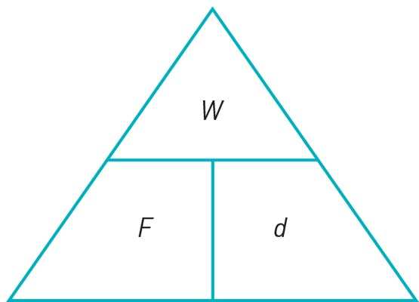

It can be used to calculate work, force applied and distance moved.

3 Write out the equation for the triangle in question 2 in word form.

Work = force applied × distance moved, or .

4 If a 48.0 g (*m*) golf ball if is travelling at 150 km h–1 (*v*) and it is 20.0 m (*h*) above the ground, calculate its kinetic energy (KE) by following the steps below.

Use 9.80 m s–2 as the value for gravity (*g*).

To convert units, use 1000 joules (J) = 1 kilojoule (kJ).

a Convert the mass (*m*) of 48 grams to kilograms. (Hint: There are 1000 g in 1 kg.)



b Convert the velocity (*v*) of 150 km h–1 to metres per second. (Hint: There are 60 seconds in 1 minute, 60 minutes in one hour, and 1000 metres in one kilometre.)



c Calculate the kinetic energy where:





(Hint: Mass (*m*) is in kg and velocity (*v*) is in m s–2.)

Remember that KE is measured in joules (J), so the final answer will be in joules.



Word detective – Match the words

5 Match the words with the correct definition.

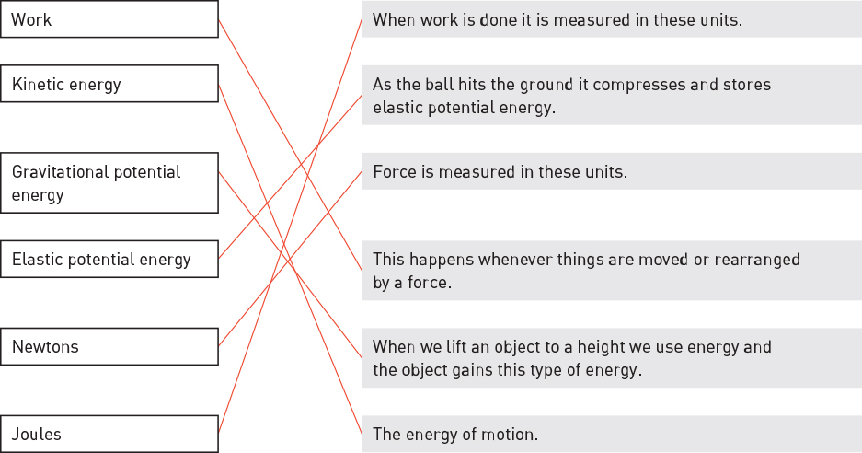

Literacy support worksheet answers

7.9 Energy is always conserved

Pages 172–173

Conservation of energy

1 What does the law of conservation of energy state?

That energy cannot be created or destroyed.

2 A student of a mass (*m*) of 60.0 kg went bungee jumping during her holidays. The bridge from which she jumped was 250 metres (*h*) above a river. She was attached to a bungee cord that had an un-stretched length of 150 metres.

You can assume that the student and the bungee cord are part of an ideal energy conversion system. This means that no energy is ‘lost’ to the environment as heat or sound.

|  |  |  |
| --- | --- | --- |
| SW0739_01095 | SW0740_01095 | SW0741_01095 |
| **A** | **B** | **C** |

**A** Shows the student just before she jumps off the bridge.

**B** Shows the student a short time later when she has fallen a distance equal to the un-stretched length of the bungee cord.

**C** Shows the student when the bungee cord has reached its maximum length and the student is momentarily stationary.

What was the student’s gravitational potential energy (GPE) at point A, on top of the bridge, if ? Hint: *m* = mass in kilograms (kg), *g* = gravity in metres per second squared (m s–2), and *h* = height in metres (m). Use 9.80 m s–2 as the value for gravity (*g*). Remember that GPE is measured in joules (J), so the final answer will be in joules.





3 What is a pendulum?

A pendulum is a mass attached by a string to a pivot point.

When a mass is drawn upwards it gains gravitational potential energy. When it is let go, the force of gravity pulls it back to its original position, converting gravitational potential energy to kinetic energy.

4 Draw an example of pendulum.

Student drawings will vary.

Word detective – Label and explain

5 Label the diagram below to show how a gravitational potential energy (GPE), elastic potential energy (EPE) and kinetic energy (KE) work on a trampoline. (Hint: Use the information in Figure 7.39 and the information on page 172 in the student book to help you.)

Student drawings will vary but will include similar diagrams to those in Figure 7.39. Diagram should include the following information:

• GPE: You have gravitational potential energy when you are high above the trampoline.

• Kinetic energy: As you start to move down you gain velocity and therefore kinetic energy.

• Elastic potential energy: Eventually you will stop moving and the trampoline will be completely stretched.

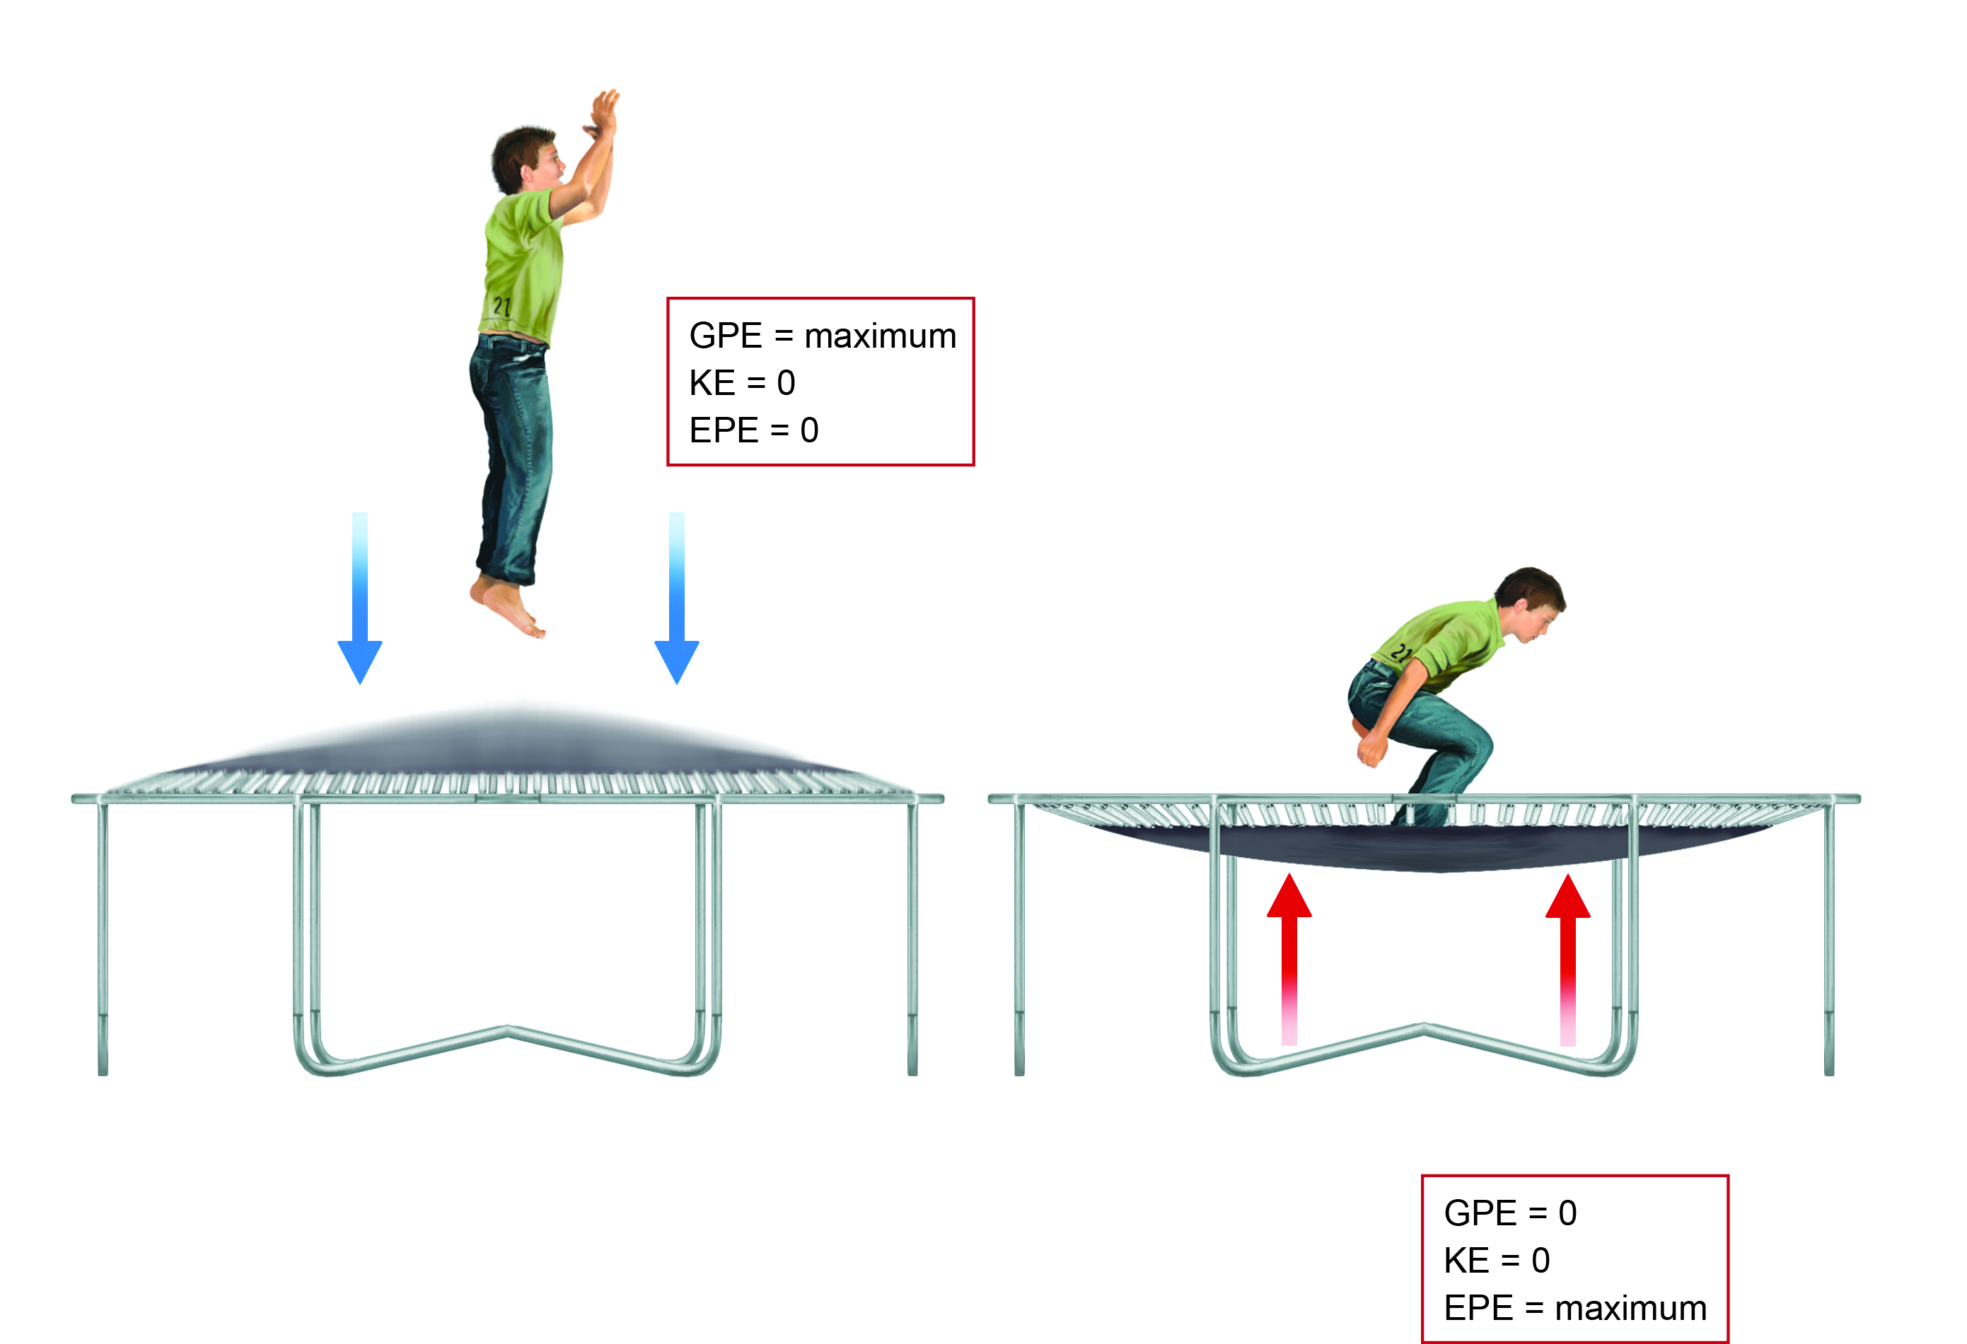

Literacy support worksheet answers

7.10 Car safety features requires an understanding of Newton’s laws and momentum

Pages 174–175

Newton’s laws and car safety features

1 While out driving in his car, Harry went around a corner too quickly, lost control of his car and ran off the road, colliding with a tree. His friend Ash was beside him in the passenger seat. Both men were wearing seatbelts. The car was travelling at a speed of 54 km hr-1 when it hit the tree.

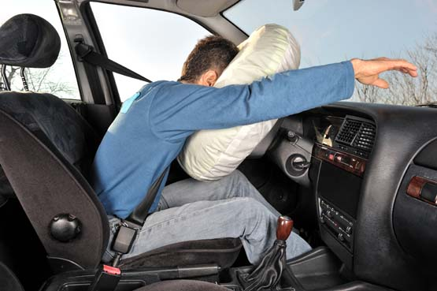

Unfortunately, Ash’s airbag did not work but Harry’s airbag did. Because of this, the time for each of their heads to come to a stop was different.

a What safety features did Harry have in his car?

Harry had seatbelts and airbags in the car.

b How does an airbag work?

A chemical reaction involving nitrogen gas causes the airbag to inflate during an accident. Air bags are designed to increase the length of time the driver has to decelerate, which decreases the amount of force exerted on the driver by the steering wheel.

2 Describe one other safety feature that might have helped to keep Harry and Ash safe.

Crumple zones, which are designed to crush during a collision and give the car more time to decelerate. This then reduces the force experienced by the passengers.

3 Why is it important to have safety features in a car?

Student answers will vary but should discuss the importance of staying safe, reducing injuries and keeping the passengers alive in case of an accident.

4 The mass of Harry’s head (*m*) is 5.0 kg, the same as Ash’s head.

Harry’s head collided with the airbag and took 0.060 seconds to stop, resulting in an acceleration (*a*)   
of –250 m s–2. (Hint: The acceleration is negative because he is coming to a stop, or decelerating.)

Ash’s head collided with the dashboard and took 0.012 seconds to come to a stop, resulting in an acceleration (*a*) of –1250 m s–2.

Calculate the average force experienced by each of Harry and Ash’s heads during the crash if net force (Fnet) = mass (in kg) × acceleration (in m s–2).



Give your answer to the nearest whole number in Newtons (N).

|  |  |
| --- | --- |
| Harry | Ash |

Word detective – True or false

6 Read the statement and circle whether it is true or false.

a When a car is travelling at 60 km/h the passengers are travelling at 80 km/h. T or F

b The slower a car stops and the smaller the mass, the smaller the force. T or F

c A rigid seatbelt will do less damage than a flexible seatbelt. T or F

d Most young babies are placed in front-facing child restraints. T or F

e Young babies must have back support when travelling in a car. T or F

f An airbag is designed to increase the length of time the driver has to decelerate. T or F

g The crumple zone increases the force experienced by passengers. T or F